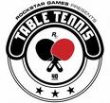
T T C

Home

Aims of Club

Expert Table Tennis Tips

Table Tennis Rules

Table Tennis Equipment

League Table

Up Coming Events


Welcome to the new NCI
Table Tennis Club Website

Our Aim is to make this site the central point for all Table Tennis activities in the National College of Ireland.

If you are interested in joining please click on the Membership Form

